Application From for ‘2026 Korean Summer Session’

RECENT
PHOTO
(3 cm X 4 cm)

- Name (should be identical with the passport name)
English ______________________________________________
(Family) (First) (Middle)
- Passport No. ___________________________________________
- Country of Birth ________________________________________________
- Country of Citizenship _________
- Gender (M/F) ___________________ _____________
- Date of Birth (MM/DD/YYYY) ______________
- Religion __________________
8) Current Address ____

9) Contact Information
- Tel. _____________
- Mobile (Including country and area codes) ____
- E-mail _____

SNS ID (Please choose one and write below) *IMPORTANT*
- What’s App Number (including country code):
- LINE ID:
- Kakaotalk ID:
- We Chat ID:

10) Special Dietary Requirement

11) Preferred roommate (please write your preferred roommate’s full name. If you want one of our Korean staff students as your roommate, please write “Korean Staff”

____________________________________________________

12) Short Personal Essay (Introduction of yourself, what you expect from this program and etc.)
. . . . .

13) Shirt Size (Please circle your size below)

SS / S / M / L / LL / 3L / 4L

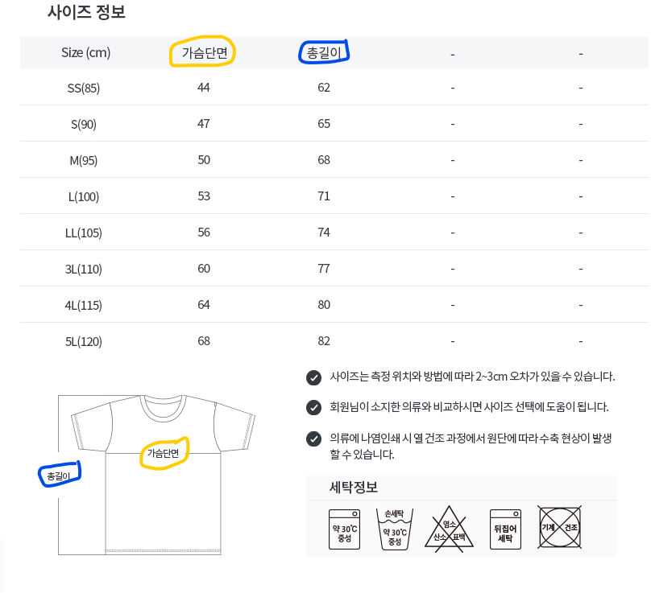
<Size Chart>
- Numbers below yellow box present ‘chest length’ (in cm)
- Numbers below blue box present ‘vertical length’ (in cm)

I certify that the information provided on this form is accurate and true.

Signature of Applicant: ______ Date of Application: ___

