**Application From for ‘2025 Korean Summer Session’**

RECENT

PHOTO

(3 cm X 4 cm)

1. Name (should be identical with the passport name)

English ______________________________________________

(Family) (First) (Middle)

1. Passport No. ___________________________________________
2. Country of Birth ________________________________________________
3. Country of Citizenship _________
4. Gender (M/F) ___________________ _____________
5. Date of Birth (MM/DD/YYYY) ______________
6. Religion __________________

8) Current Address ____

9) Contact Information

- Tel. _____________

- Mobile (Including country and area codes) ____

- E-mail _____

SNS ID (Please choose one and write below)

* What’s App Number (including country code):
* LIND ID:
* Kakaotalk ID:
* We Chat ID:

10**) Special Dietary Requirement**

11) Preferred roommate (please write your preferred roommate’s full name. If you want one of our Korean staff students as your roommate, please write “Korean Staff”

____________________________________________________

12) Short Personal Essay (Introduction of yourself, what you expect from this program and etc.)

. . . . .

13) Shirt Size (Please circle your size below)

SS / S / M / L / LL / 3L / 4L

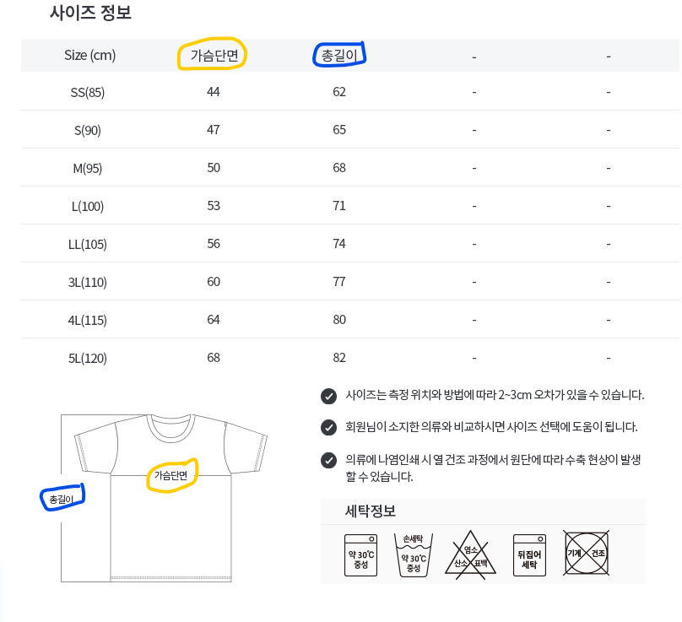

<Size Chart>

* Numbers below yellow box present ‘chest length’ (in cm)
* Numbers below blue box present ‘vertical length’ (in cm)

***I certify that the information provided on this form is accurate and true.***

Signature of Applicant: ______ Date of Application: ___